**SIMULATION OF AN INTEGRATED ADVANCED DRIVER ASSISTANCE SYSTEM (ADAS) FOR AUTONOMOUS AND SEMI-AUTONOMOUS VEHICLES**

**A INTERNSHIP TRAINING REPORT**

***Submitted by***

**01FE21BAR052 – SAMARTH IJANTAKAR**

***In the completion of internship training project***

**Under the guidance of:**

**Prof. Shridhar Doddamani**

***Bachelor of Engineering***

**IN**

**MECHANICAL ENGINEERING**

**KLE TECHNOLOGICAL UNIVERSITY, HUBBALLI**

**APRIL 2025**

**DEPARTMENT OF MECHANICAL ENGINEERING**

**Certified that the project work entitled**

SIMULATION OF AN INTEGRATED ADVANCED DRIVER ASSISTANCE SYSTEM (ADAS) FOR AUTONOMOUS AND SEMI-AUTONOMOUS VEHICLES

Is a bonafide work carried out by

Terance N, in partial fulfillment for the award of degree of Bachelor Engineering in MECHANICAL DEPARTMENT of the KLE Technological University, Hubballi during the year 2024-25. It is certified that all corrections/suggestions indicated for internal assignment have been incorporated in the report deposited in the departmental library. The project report has been approved as it satisfies the academic requirements in respect of project work prescribed for the Bachelor of Engineering Degree.

Signature of the guide Signature of the HOD

Prof. Shridhar Doddamani Prof. Sachin K[ar](https://learn.kletech.ac.in/user/profile.php?id=146)adgi

Name of the Examiners Signature with Date

1.

2.

ACKNOWLEDGEMENT

We have put our sincere efforts in this project. However, it would not have been possible without the kind support and help of many individuals. We would like to extend our sincere thanks to all of them.

We are highly indebted to our guide **Prof. Shridhar Doddamani** for their guidance and constant supervision as well as for providing necessary information regarding the project & also for their support in completing the project.

We would like to express our gratitude towards all the members of the department of Mechanical Engineering for their kind cooperation and encouragement which helped us in completion of this project.

We would like to express our special gratitude and thanks to **Head of the Department Prof. Sachin K**[**aradgi**](https://learn.kletech.ac.in/user/profile.php?id=146) for giving us attention and time.

Our thanks and appreciations to all our classmates and people who have willingly helped us out with their abilities.

01FE21BME135

ABSTRACT

This report delves into the conceptualization, design, and implementation of an Integrated Advanced Driver Assistance System (ADAS) for autonomous and semi-autonomous vehicles. Leveraging the Gazebo simulation environment, the project recreates real-world driving conditions, including traffic lights, road symbols, and two-lane roads, to provide a comprehensive test bed for the ADAS features. A camera-equipped vehicle is integrated with computer vision algorithms to process real-time visual data, facilitating functionalities such as lane detection, cruise control, T-junction navigation, traffic light recognition, and satellite navigation. These systems work in unison to enhance decision-making capabilities and ensure the safety of autonomous operations.

The project emphasizes modular and scalable architecture to enable seamless integration of various ADAS functionalities.

Beyond technical development, the project underscores the importance of testing and validation, with rigorous procedures ensuring accuracy and reliability within the simulated environment. The work provides a foundation for real-world applications by demonstrating the feasibility of ADAS systems in a controlled virtual setting. The comprehensive documentation and results outlined in this report aim to contribute to the growing body of research in autonomous vehicle technology, paving the way for future innovations in safer and more efficient transportation solutions.

**TABLE OF CONTENTS**

| **Chapter No** | **Title of the chapter** | **Page No.** |
| --- | --- | --- |
|  | Acknowledgement | I |
|  | Abstract | II |
|  | List of contents | III |
|  | List of tables | V |
|  | List of figures | VI |
| Chapter 1 | Introduction | 1 |
| Chapter 2 | Problem Statement | 2 |
|  | 2.1 Motivation | 2 |
|  | 2.2 Goals and Objectives | 2 |
| Chapter 3 | Literature Survey | 4 |
|  | 3.1 Research related to problem definition to identify state of art methods presently in practice | 4 |
| Chapter 4 | Requirement modeling and analysis | 8 |
|  | 4.1 End Users | 8 |
|  | 4.2 Analyze End User Needs | 9 |
|  | 4.3 Generate Initial Requirement List | 11 |
|  | 4.4 Final Problem Statement | 12 |
|  | 4.5 Brainstorming | 12 |
|  | 4.5.1 Outcomes of the Brainstorming | 12 |
| Chapter 5 | 5.1 Architecture of the System | 14 |
|  | **Arc** 5.2 Architectural Layout of the ADAS System | 14 |
|  | 5.3 Flowchart of the ADAS System | 15 |
| Chapter 6 | 6.1 Methodology | 17 |
|  | 6.1.1 Black Box of the Integrated System | 17 |
|  | 6.1.2 Block Diagram of the Integrated System | 18 |
|  | 6.1.3 Functions and Sub-Functions of the Integrated System | 19 |
|  | 6.1.4 Use Case Diagram of the Integrated System | 21 |
|  | 6.2 Software of the Integrated System | 23 |
|  | 6.2.1 3D World of the ADAS System | 24 |
|  | 6.2.2 Lane Detection | 25 |
|  | 6.2.3 Traffic signs board Detection | 26 |
|  | 6.2.4 Traffic signal detection  6.3 Working model of the project | 27  29 |
| Chapter 7 | Results | 32 |
| Chapter 8 | Conclusion | 34 |
|  | REFERENCES | 35 |
|  |  |  |
|  |  |  |
|  |  |  |
|  |  |  |
|  |  |  |
|  |  |  |
|  |  |  |
|  |  |  |
|  |  |  |
|  |  |  |
|  |  |  |

| **LIST OF TABLES** | | |
| --- | --- | --- |
| **Table No.** | **Title of the Tables** | **Page No** |
| Table 4.2 | Analyze end user needs | 9-10 |
| Table 4.3 | Generate initial requirements of the System | 11 |
| Table 6.1.3a | Functions of the ADAS system | 19 |
| Table 6.1.3b | Sub-Functions of the ADAS system | 19-21 |
| Table 6.2 | Software used for the ADAS System | 23 |

| **LIST OF FIGURES** | | |
| --- | --- | --- |
| **Figure No.** | **Title of the Figures** | **Page No** |
| Fig 5.1a | Architectural Layout of the ADAS System | 14 |
| Fig 5.1b | Network Architecture of the ADAS System | 15 |
| Fig 5.2a | Order Flowchart of the ADAS System | 16 |
| Fig 5.2b | Traffic sign boards and Traffic signal Flow Chart of the ADAS System | 16 |
| Fig 6.1.1 | Black Box of the ADAS System | 17 |
| Fig 6.1.2 | Simulation Block Diagram of ADAS System | 18 |
| Fig 6.1.4 | Use Case of the ADAS System | 22 |
| Fig 6.2.1 | 3D World of the ADAS System | 24 |
| Fig 6.2.2 | Lane Detection | 25 |
| Fig 6.2.3a | Traffic sign board Detection | 26 |
| Fig 6.2.3b | Traffic sign board Detection | 26 |
| Fig 6.2.4a | Traffic signal Detection | 27 |
| Fig 6.2.4b | Traffic signal Detection | 27 |
| Fig 6.2.4c | T-junction Navigation | 28 |
| Fig 6.3a | Final prototype of the project for traffic signal detection | 29 |
| Fig 6.3b | Final prototype of the project for traffic signal detection | 30 |
| Fig 6.3c | Final working of T-junction for ADAS System | 31 |
| Fig 7a | Final model | 33 |

**CHAPTER 1**

**INTRODUCTION**

The increasing demand for autonomous and semi-autonomous vehicles has driven the development of advanced systems capable of supporting intelligent decision-making and enhancing safety on the roads. At the core of these innovations lies the Advanced Driver Assistance System (ADAS), a critical technology designed to bridge the gap between manual driving and full autonomy. ADAS integrates cutting-edge technologies, including computer vision, path planning, and real-time sensor data processing, to enable vehicles to navigate safely and efficiently in dynamic driving environments.

This project focuses on the simulation of an Integrated ADAS within the Gazebo simulation environment, aiming to replicate real-world driving conditions to test and refine the system's functionalities. The simulated environment includes essential elements such as traffic lights, road symbols, and two-lane roads, providing a realistic testbed for developing features like lane assist, cruise control, T-junction navigation and traffic light recognition. By integrating these features, the system aims to achieve autonomous movement while ensuring reliability and safety.

The project not only addresses the technical challenges associated with developing autonomous vehicle systems but also highlights the importance of modular design and scalability. Through rigorous testing and validation in a simulated environment, the project aspires to contribute valuable insights and solutions to the ever-evolving domain of autonomous vehicle technology.

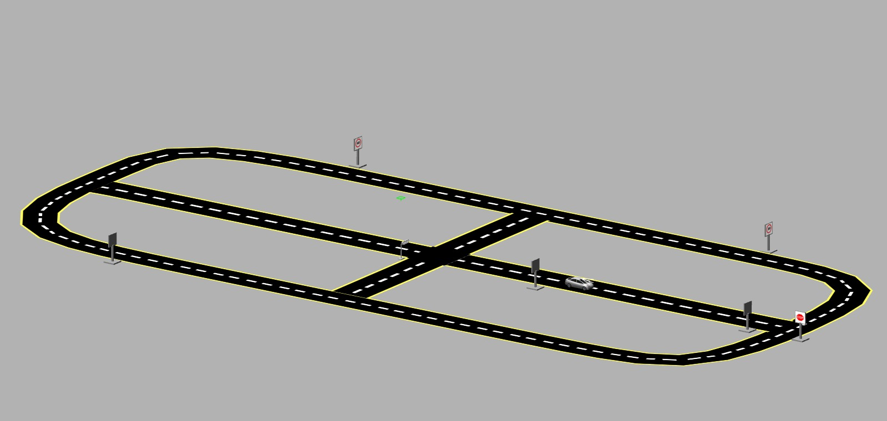

*Fig: 1a Simulation World*

**CHAPTER 2**

**PROBLEM STATEMENT**

“SIMULATION OF AN INTEGRATED ADVANCED DRIVER ASSISTANCE SYSTEM (ADAS) FOR AUTONOMOUS AND SEMI-AUTONOMOUS VEHICLES.”

**2.1 Motivation**

The global push towards autonomous and semi-autonomous vehicles is fueled by the promise of safer, more efficient, and sustainable transportation. Despite significant advancements, challenges such as accident prevention, efficient navigation, and adherence to traffic regulations remain critical to achieving widespread adoption of these systems. Advanced Driver Assistance Systems (ADAS) serve as a pivotal stepping stone, enabling vehicles to perform tasks with higher precision while ensuring safety and comfort for passengers. Developing and refining ADAS in controlled environments allows for the exploration of these challenges without the risks and constraints of real-world testing.

The motivation behind this project lies in addressing the complexities of autonomous decision-making in diverse driving scenarios. Real-world roads are dynamic, filled with challenges such as navigating intersections, recognizing traffic signs and lights, and maintaining lane discipline amidst varying conditions. Simulating these conditions provides a safe, cost-effective, and scalable platform to develop solutions that mirror real-world scenarios. By utilizing the Gazebo simulation environment, this project aims to replicate these challenges, creating a virtual testing ground for innovative ADAS features. Additionally, the project is driven by the potential impact on road safety. Studies suggest that human error is a leading cause of road accidents, and implementing robust ADAS features can significantly reduce these risks. By developing a system that integrates traffic light recognition, T-junction navigation, cruise control, and lane assist, the project aspires to contribute to the creation of autonomous systems that prioritize safety and decision-making. The broader goal is to lay the groundwork for future advancements in autonomous driving technologies, addressing not only the technical aspects but also the societal need for safer and smarter transportation systems.

**2.2 Goals and Objectives**

1. Develop a Simulated Environment: Create a realistic driving environment in the Gazebo simulation platform, incorporating traffic lights, road symbols, and two-lane roads to replicate real-world driving conditions.
2. Integrate Camera-Based Vision: Equip the simulated vehicle with a camera and implement computer vision algorithms to detect and interpret traffic lights, road symbols, and lane markings.
3. Implement Lane Assist Feature: Enable the vehicle to detect lanes using image processing and stay centered within the designated lane for improved lane discipline and safety.
4. Design Cruise Control Functionality: Develop a cruise control system that allows the vehicle to maintain a steady speed and adjust dynamically to road and traffic conditions.
5. Develop T-Junction Navigation: Implement algorithms for autonomous decision-making at T-junctions, enabling the vehicle to turn left, right, or proceed straight based on the environment.
6. Incorporate Traffic Light Recognition: Build a system capable of identifying and reacting appropriately to traffic signals, ensuring compliance with traffic rules.
7. Ensure Cross-Intersection Movement: Develop logic for safely navigating cross-intersections using a combination of traffic light recognition and obstacle detection.
8. Perform System Testing and Validation: Rigorously test all ADAS features within the simulated environment to ensure their accuracy, reliability, and real-world applicability.
9. Deliver Comprehensive Documentation: Provide detailed documentation covering the system architecture, algorithms, implementation processes, testing procedures, and project outcomes for future reference and scalability.

**CHAPTER 3**

**LITERATURE SURVEY**

The development of an Advanced Driver Assistance System (ADAS) is rooted in extensive research across computer vision, path planning, and autonomous navigation. Existing literature highlights the role of simulation environments like Gazebo in creating controlled and reproducible scenarios for testing autonomous driving features. Key studies have explored algorithms for lane detection using edge detection and deep learning models, as well as the traffic light recognition. Path planning methods such as A* and Dijkstra’s algorithms are widely acknowledged for their efficiency in routing and decision-making.

Additionally, research on integrating ADAS functionalities demonstrates the importance of modular architectures for scalability and reliability. Studies emphasize the challenges of real-world applications, including dynamic traffic scenarios and environmental variability, underlining the need for robust testing in simulated environments. This project builds upon these foundational works, adopting state-of-the-art methodologies and customizing them to address specific challenges in autonomous navigation and decision-making.

**3.1 Research related to problem definition to identify state of art methods presently in practice**

This aids in comprehension of the remedies that are now available on the market for the stated problem. It aids in understanding the degree of complexity needed to tackle the issue and how to distinguish approach from others.

The paper explores the use of driving simulators to analyze the impact of cooperative ADAS, such as merging assistants and hazard warnings, on driver behavior and interactions. It finds that while these systems can have positive effects, they can also lead to negative consequences, highlighting the importance of careful design and implementation to ensure safety and efficiency in road traffic. [1].

The paper proposes a modular architecture for designing sensor models for ADAS virtualization. The architecture represents the car's surroundings as a list of objects and modifies this list during the virtual sensing process. The result can then be used to stimulate ADAS function algorithms. As an example, the paper constructs a sensor model that employs stochastic variations of target object positions. This approach aims to improve development quality and speed for ADAS by providing a realistic virtual environment before hardware prototypes are available. [2].

The paper proposes a framework for testing ADAS using a combination of simulation and hardware-in-the-loop (HIL) techniques. The framework captures real-world driving data from a test vehicle equipped with a radar sensor and GPS navigation. This data is then used to create a detailed virtual environment within a simulation, allowing for testing of ADAS strategies. The framework also enables HIL testing by connecting the simulation to an engine test bench, allowing for evaluation of ADAS performance based on metrics like engine emissions and fuel consumption. The approach is flexible and can be extended to include additional sensor stimulation and automatic traffic object generation based on real-world data. [3].

The paper describes a versatile driving simulation platform developed by Siemens PLM Software that can be used for various types of testing and validation of Advanced Driver Assistance Systems (ADAS). The platform includes components such as a virtual environment, vehicle models, sensor models, and human-machine interface models. The paper demonstrates the platform's usefulness by showcasing its application to autonomous driving functionalities like adaptive cruise control and autonomous intersection crossing. Additionally, the paper highlights key features of the platform, such as its flexibility and scalability [4].

The paper investigates the effectiveness of simulation-based testing for Advanced Driver Assistance Systems (ADAS) using two different commercial simulators. The authors employ Search-Based Software Testing (SBST) to generate critical test scenarios for a pedestrian vision detection system. They find that SBST can be used effectively in both simulators to identify weaknesses in the ADAS. However, the specific test outputs, such as safety violations and the dynamics of cars and pedestrians, can vary significantly between the two simulators. The authors recommend using multiple simulators for robust testing and basing test objectives on measures that are less dependent on the internal workings of the simulators.[5].

The paper presents the design and development of a flexible, modular driving simulator tailored for investigating the effects of automation and V2X communication on drivers. The simulator is linked to SUMO for traffic simulations and ROS for architecture management. It was validated through experiments and compared with field tests and different path tracking algorithms, demonstrating good and efficient performance. [6].

The paper compares three different nonlinear model-based approaches for the inner-loop controllers of a hierarchical two-loop ACC system: PI+GS, B-BAC, and NMPC. The performance of each ACC system is tested under the same realistic scenarios for distance tracking and switching modes. The comparative criteria include driving safety, comfort, and fuel efficiency (BSFC). The results demonstrate that all control algorithms meet safety and car-following requirements, but offer slightly different levels of comfort and fuel consumption depending on the traffic situation and operating mode.[7].

The paper proposes a multi regime car-following model for ACC-CACC vehicles that combines a realistic ACC-CACC system with driver intervention for longitudinal motions. The model assumes that a human driver resumes vehicle control either based on their assessment or after a collision warning. The model was tested in various scenarios, including regular and extreme safety-concerned maneuvers. The simulation results show that the proposed model is collision-free in the full-speed-range operation with leader accelerations within −1 to 1 m/s² and in approaching and cut-out scenarios. This indicates that the model can produce realistic vehicle response without causing collisions in regular scenarios for vehicle string operations.[8].

The paper proposes a decentralized framework for connected autonomous vehicles to make cooperative lane-changing decisions. The framework consists of three modules: state prediction, candidate decision generation, and coordination. Each vehicle makes decisions independently, using cooperative car-following models for prediction, an incentive-based model for generating candidates, and an algorithm to avoid collisions or traffic deterioration. The paper evaluates the effects of this framework on traffic stability, efficiency, homogeneity, and safety through numerical simulations, finding promising results for improving traffic dynamics.[9].

The paper introduces a simulation framework for testing automated driving systems using CarMaker, ROS, and real traffic data. The framework allows for testing various scenarios by varying topology, vehicle, and communication parameters. The authors demonstrate the benefits of collective perception (sharing sensor data among vehicles) for freeway merging, using metrics like vehicle awareness and maneuver planning time. [10].

The paper proposes a novel approach for testing vision-based ADAS by combining simulations with recorded test drive data to create a more reliable and reproducible reference model. This approach can be used in early stages of the design process to evaluate algorithms and reduce the need for extensive real-world testing. The paper demonstrates the effectiveness of this approach by testing a vision-based collision mitigation system on German highway recordings. [11].

The paper introduces a new spectral HDR camera model in the ADAS simulation platform PreScan. This model allows for high color depth, broad spectrum, and physically correct image generation. The model simulates light in the 320-1500 nm spectral range,traversing through various media and lenses before producing the final image signal. Other features include a depth resolution of 20 bit per waveband and an increased dynamic range. This model is essential for supporting the development of ADAS and Automated Driving Systems by providing a realistic and accurate simulation of automotive cameras.[12].

The paper presents a Hardware-in-the-Loop testing setup to evaluate a proprietary algorithm for multi-class object detection in an ADAS platform. The setup uses a real automotive Camera-in-the-Loop to simulate various driving scenarios and test the algorithm's performance under different conditions. This approach allows for early identification of deficiencies and ensures the algorithm meets the specified requirements before release.[13].

The paper proposes a methodology to learn individual driver/vehicle characteristics during lane changes and develop a personalized ADAS that provides more effective and acceptable recommendations. The authors develop a two-layer model to describe lane change maneuver kinematics, with the lower layer representing the kinematic model and the higher layer establishing the model parameter values for individual drivers. The methodology is evaluated using an actual vehicle and three different drivers, demonstrating its effectiveness in modeling individual responses. [14].

The research proposes a method to estimate the practical effectiveness of 6 ADAS systems (BSW/LCW, FCW, IMA, PCAM, LDW, LTA) in avoiding crashes on different roadways. The method uses meta-analysis, quasi-induced exposure, and Monte Carlo simulation to estimate the distribution of effectiveness factors across the driver population and simulate practical ADAS effectiveness.[15]

The goal of this literature review is to provide readers with a comprehensive understanding of the body of knowledge, research, and advancements relevant to the Advanced Driver Assistance System (ADAS) and its integration into autonomous and semi-autonomous vehicle technologies. This review aims to highlight the methodologies, innovations, and challenges associated with developing and implementing ADAS features to enhance safety, decision-making, and overall driving efficiency.

**CHAPTER 4**

**REQUIREMENT MODELING AND ANALYSIS**

The fundamental stages in the development of an Advanced Driver Assistance System (ADAS) are requirement modeling and analysis, which offer a structured approach to identifying, assessing, and prioritizing the specifications that will guide the design and implementation phases. This critical process ensures that the final system meets quality benchmarks, user needs, and regulatory standards, laying the groundwork for a successful and reliable deployment of ADAS technologies in autonomous and semi-autonomous vehicles

**4.1 End Users:**

The Advanced Driver Assistance System (ADAS) can benefit a wide range of stakeholders involved in the development, implementation, and utilization of autonomous and semi-autonomous vehicle technologies.

**Automotive Manufacturers:** Automotive companies producing vehicles equipped with autonomous and semi-autonomous features can leverage ADAS for enhancing safety, efficiency, and user experience. Industries such as passenger vehicles, commercial transportation, and luxury automotive sectors are prime examples.

**Vehicle Operators:** Drivers and operators of vehicles with ADAS benefit from features like lane assist, cruise control, and traffic light recognition, which reduce driver workload and enhance road safety, particularly in challenging conditions.

**Testing and Validation Teams:** Professionals responsible for evaluating vehicle safety and functionality can use the ADAS system to conduct thorough simulations and ensure compliance with industry standards and regulations.

**Product Designers and Engineers:** Automotive engineers and designers working on integrating ADAS into vehicle platforms can utilize the system's modular architecture to optimize design and improve performance..

**Fleet Managers:** Organizations managing fleets of vehicles can benefit from ADAS features like satellite navigation and cruise control, which enhance fuel efficiency, reduce accidents, and improve route optimization.

**Traffic Safety Regulators:** Government and regulatory bodies can adopt insights from ADAS to establish safety benchmarks and promote safer driving practices through the integration of advanced vehicle technologies.

**Research and Development Teams:** Researchers exploring advancements in autonomous systems can use ADAS as a testing ground for innovating features and addressing emerging challenges in the domain of vehicular autonomy.

**Maintenance and Support Teams:** Technicians and engineers responsible for the upkeep of autonomous vehicle systems rely on ADAS diagnostics and fault detection features to ensure operational reliability.

**Technology Integrators:** System integrators working on embedding ADAS into existing vehicle platforms can streamline processes and enhance compatibility across various automotive models.

**Insurance Companies:** Insurance providers can leverage data from ADAS features to assess driving behavior, offer tailored policies, and incentivize safer driving practices.

**4.2 Analyze End user needs:**

Table 4.2 refers to, analyzing the end-user needs which reveals a distinct pattern: a widespread need for a flexible, adaptive, and effective manufacturing system. Flexibility, accurate assembly, efficient material handling, and the capacity to quickly incorporate new products are the main points to focus. The Integrated Multi-Platform Automation System was developed with this insight as its base in order to precisely meet these crucial requirements.

*Table 4.2 Analyze End User Needs*

| **NO.** | **End User Statements** | **Interpreted Need** |
| --- | --- | --- |
| 1 | "We require a vehicle system that ensures reliable and accurate performance for enhanced safety in dynamic driving conditions." | The user requires an ADAS capable of real-time monitoring and analysis to maintain safety and accuracy in dynamic road conditions, enhancing driver and passenger security. |
| 2 | "Navigating intersections and traffic lights is challenging, and we need a system that can make informed decisions in complex traffic scenarios." | The user needs a system that integrates traffic light detection and decision-making algorithms to handle intersections efficiently and follow traffic rules effectively. |
| 3 | "Maintaining lane discipline on highways and during turns is critical for safe driving." | The user requires an ADAS with reliable lane detection and lane-keeping assist functionality to ensure accurate lane discipline and enhance highway driving safety. |
| 4 | “We need a system that minimizes driver fatigue and assists with vehicle control during long journeys.” | The customer seeks a system with features like adaptive cruise control and automated lane centering to reduce driver workload and ensure comfort on long drives. |
| 5 | "Traffic congestion demands a solution that can help reduce stress while maintaining efficiency.." | The user requires an ADAS that includes stop-and-go traffic assistance and adaptive speed management to enhance vehicle control in congested environments. |
| 6 | "Obstacle detection and avoidance are crucial for ensuring the safety of pedestrians and vehicles in urban areas." | The customer needs a robust ADAS with real-time object detection and collision avoidance systems to prevent accidents and ensure smooth navigation in crowded areas. |
| 7 | "We need a system that can adapt to evolving road conditions, such as construction zones, weather changes, or unclear road markings." | The end user requires an adaptive ADAS capable of interpreting unpredictable road conditions and making informed driving decisions to maintain safety and efficiency. |
| 8 | "Our priority is to enhance driving safety and reduce the likelihood of accidents caused by human error.." | The user seeks an ADAS with advanced driver monitoring, automated braking, and predictive risk assessment to minimize human errors and enhance overall road safety. |
| 9 | "We aim to improve driving efficiency by reducing fuel consumption and optimizing vehicle performance." | The user requires an ADAS integrated with eco-driving features, such as route optimization and speed regulation, to improve fuel efficiency and minimize environmental impact. |
| 10 | "Adaptability is essential for accommodating both experienced and novice drivers, ensuring ease of use for everyone." | The end user needs an intuitive ADAS with customizable settings and user-friendly interfaces that cater to a diverse range of drivers, providing both safety and ease of operation. |

**4.3 Generate initial requirement list:**

The requirement list serves as the cornerstone of the project's development and is compiled from a range of sources, including client specifications, team insights, and in-depth surveys. This compilation, which is shown in Table 4.3, ensures a thorough understanding of expectations, allowing for the creation of a customized system that exactly matches stakeholder needs and project objectives.

*Table 4.3 Generate initial requirements of the System*

| **SI. NO** | **SOURCE** | **REQUIREMENT** |
| --- | --- | --- |
| **1** | **CLIENT** | Ensure the simulation environment accurately replicates real-world driving conditions to test ADAS features effectively. |
| **2** | **CLIENT** | Provide precise and customizable scenarios for testing various ADAS functionalities, such as lane keeping, obstacle avoidance, and adaptive cruise control. |
| **3** | **CLIENT** | Incorporate real-time feedback mechanisms to evaluate the system's safety performance and compliance with regulatory standards. |
| **4** | **CLIENT** | Deliver a scalable simulation platform that can adapt to evolving ADAS requirements and support advanced autonomous driving features. |
| **5** | **CLIENT** | Implement stringent quality assurance protocols to validate simulation results and ensure consistency with real-world data. |
| **6** | **CLIENT** | Ensure seamless integration of diverse technologies, such as sensor models and AI algorithms, for a comprehensive ADAS testing experience. |
| **7** | **CLIENT** | Provide a user-friendly interface for configuring and controlling simulations, enabling easy use by engineers and testers. |
| **8** | **CLIENT** | Simplify the testing process by automating scenario generation and result analysis to enhance efficiency. |
| **9** | **TEAM** | Develop comprehensive documentation, including guidelines and troubleshooting manuals, to support users in operating the simulation platform effectively. |
| **10** | **TEAM** | Create a routine update mechanism to keep simulation tools aligned with advancements in ADAS technologies and industry standards. |
| **11** | **SURVEY** | Ensure robust integration of the simulation platform with existing testing infrastructure to facilitate uninterrupted ADAS development workflows. |
| **12** | **SURVEY** | Implement strong access controls and encryption to secure simulation data and protect it from unauthorized access and potential breaches. |

**4.4 Final Problem Statement**

The project aims to simulate an Integrated Advanced Driver Assistance System (ADAS) within a Gazebo environment to support autonomous and semi-autonomous vehicle functionalities. The simulation environment will include traffic lights, road symbols, and two-lane roads. A camera-equipped car, powered by computer vision algorithms, will identify traffic lights, road symbols, and lanes, providing critical data for self-driving capabilities. The ADAS will integrate features such as lane assist, cruise control, T-junction navigation, traffic light recognition, and satellite navigation, enabling autonomous movement within the simulated environment and enhancing the vehicle's decision-making and safety features.

**4.5 Brainstorming**

Brainstorming is a vital step in designing a **Simulation-Based Advanced Driver Assistance System (ADAS)**. This collaborative and creative process enables the team to generate innovative ideas, explore diverse perspectives, and develop robust solutions to tackle challenges in ADAS testing and validation effectively.

**4.5.1 Outcomes of Brainstorming**

Brainstorming Outcomes for Simulation-Based ADAS:

1. **Applications:**

* Highway Lane Keeping and Lane Departure Warning Testing
* Adaptive Cruise Control in Urban Traffic Simulation
* Pedestrian and Cyclist Detection and Avoidance
* Testing Collision Mitigation and Automatic Emergency Braking
* Autonomous Parking Assistance Scenarios

**2. Key Components:**

- Virtual Sensors (Radar, LIDAR, Camera Models)

- Dynamic Traffic Flow Simulation Modules

- High-Fidelity Physics Engine for Accurate Vehicle Dynamics

- Environmental Condition Simulators (Rain, Fog, Night Driving)

- Cloud-Integrated Data Analytics Platform

**3. System Features:**

- Customizable Scenario Generation for Diverse Traffic Situations

- Real-time Performance Monitoring and Feedback

- AI-Powered Anomaly Detection and Crash Prevention Analysis

- Integration of Digital Twins for Real-World Testing Validation

- Comprehensive Test Reports with Detailed Metrics and Visualizations

**4. Target Industries:**

- Automotive Manufacturing and Testing

- Intelligent Transportation Systems Development

- Urban Mobility and Smart City Initiatives

- Logistics and Fleet Management Services

- Defense Applications for Autonomous Convoy Vehicles

**5. Target Users:**

**-** Automotive OEMs and Tier 1 Suppliers

**-** Independent ADAS Validation Laboratories

- Government Agencies for Safety Compliance Testing

- Educational Institutions for R&D in Autonomous Driving

- Insurance Companies for Risk Analysis and Claim Validation

**CHAPTER 5**

**ARCHITECTURE OF THE SYSTEM**

**5.1 Architectural Layout of the ADAS System:**

Fig 5.1a shows the architectural layout which includes key units that work together seamlessly to drive efficiency: a GUI Control unit that facilitates user interaction; an actuation unit that manages hardware; a power unit that supplies energy; a storage unit that manages data; a processing unit that executes operations; and a software unit that harmonizes these components. This well-thought-out design guarantees an efficient and networked system for maximum performance in the Integrated Multi-Platform Automation project.

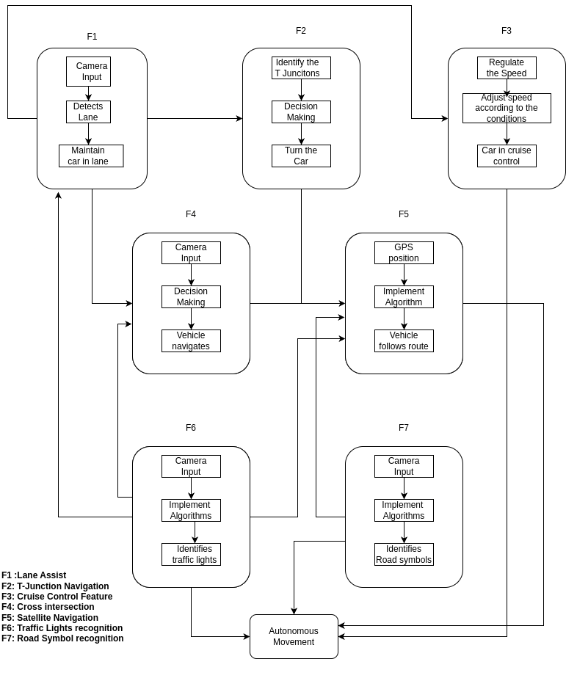

*Fig 5.1a Architectural Layout of the ADAS System*

**Network Architecture of the ADAS System:**

The Python and programming language enable a seamless interaction between various modules in the simulation of the ADAS system, including Lane Detection, Traffic Signal Recognition, Traffic Sign Recognition, and the Vehicle Control System, as depicted in Fig. 6.1b. These modules work collaboratively, ensuring precise real-time decision-making and control for autonomous navigation. Effective coordination is achieved through bidirectional data flow between the modules and the ROS 2 middleware, facilitating efficient communication and modular integration. Moreover, Gazebo simulation and DDS-based communication enhance the system’s interoperability and data exchange, creating a responsive, scalable, and intelligently controlled environment for testing and validating ADAS functionalities.

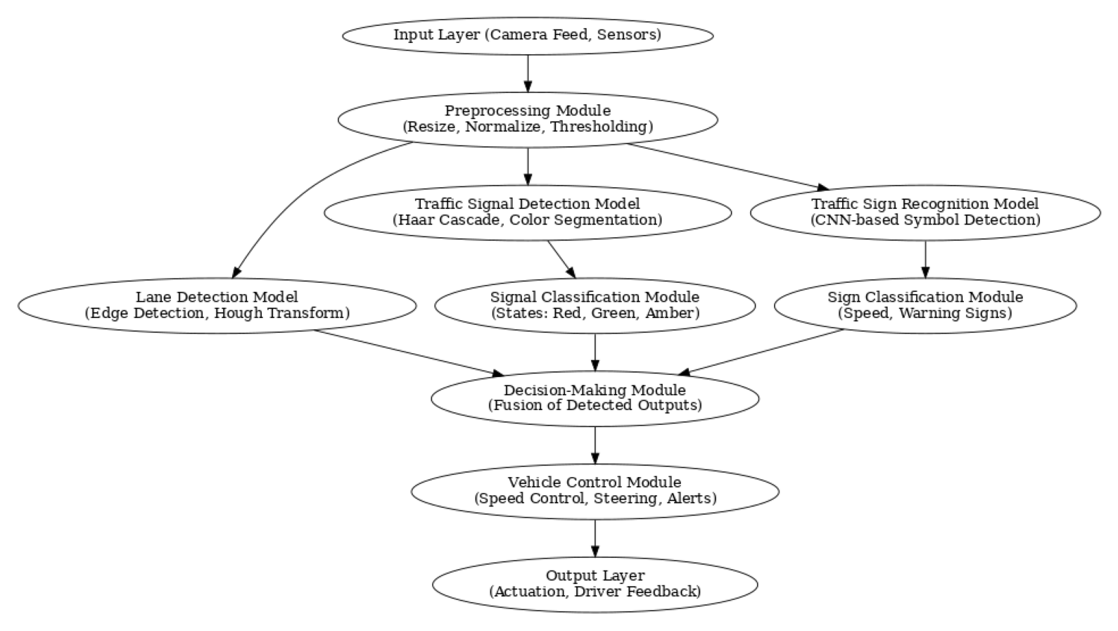

*Fig 5.1b Network Architecture of the ADAS System*

**5.2 Flowchart of the ADAS System:**

The Fig. 5.1a, Fig. 5.1b represents the flowcharts for lane detection, traffic signal detection, and traffic sign recognition, respectively, within the simulation of the ADAS system. These flowcharts provide detailed representations of individual ADAS functionalities while ensuring smooth sequential integration with the overall system. Each flowchart serves as a comprehensive guide for its respective function, offering clear insight into the processes involved and their interconnections. This structured approach ensures a coordinated and efficient workflow within the simulation of the Advanced Driver Assistance System, enabling accurate testing and validation of the self-driving car's capabilities.

* **Order Flowchart of theADAS System**

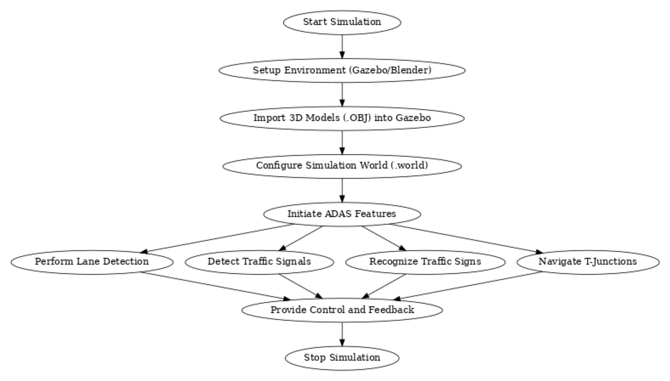

*Fig 5.2a Order Flowchart**of the ADAS System*

* **Traffic Sign boards and Traffic Signal Flow Chart of the ADAS System**

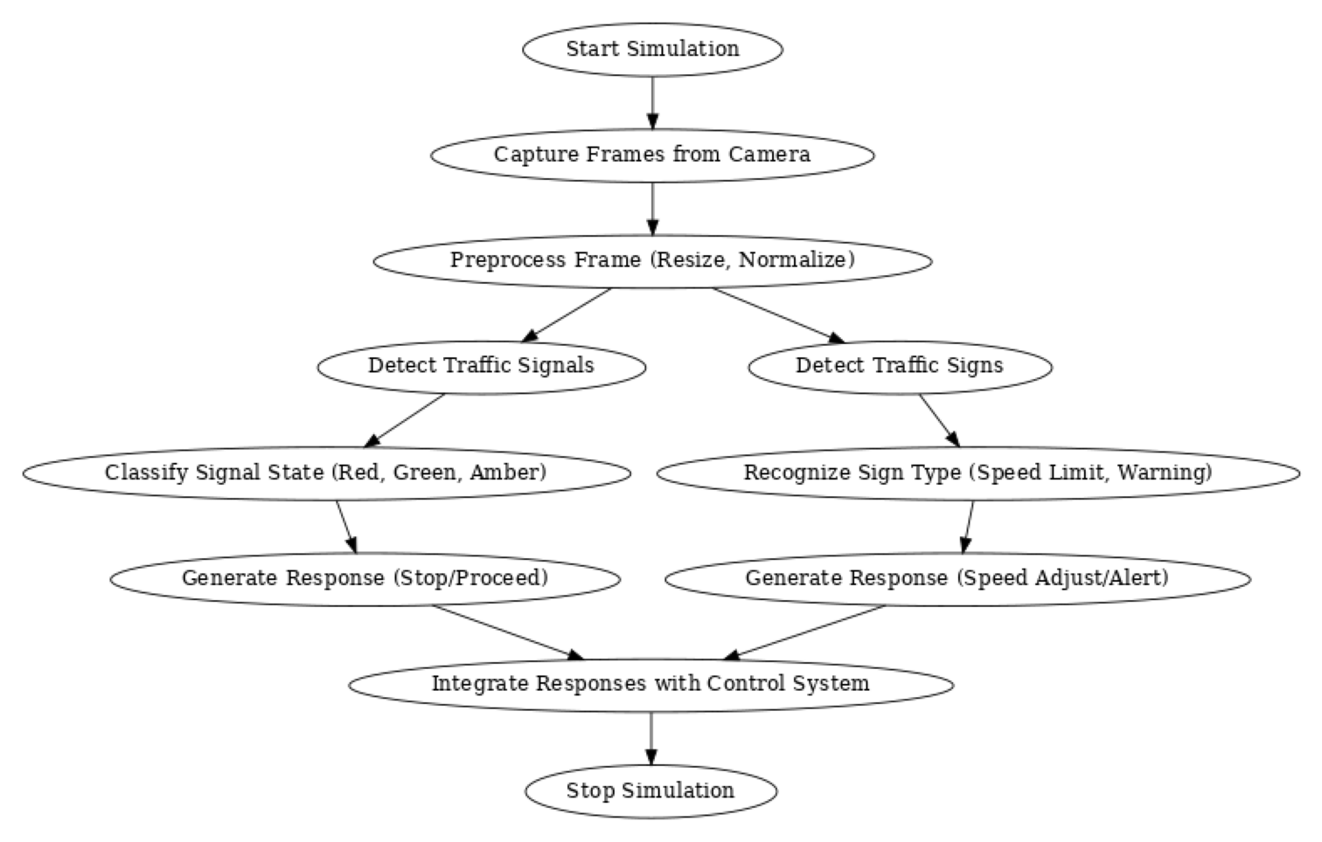

*Fig 5.2b Traffic Sign boards and Traffic Signal Flow Chart of the ADAS System*

**CHAPTER 6**

**METHODOLOGY**

**6.1.1 Black Box of the ADAS System**

The **Simulation ADAS System's** core functionality can be abstractly represented as a black box, as shown in Fig 6.1.1. This black box accepts inputs such as sensor data (from cameras), pre-defined simulation scenarios (including road conditions and traffic density), and control parameters for the ADAS system. Inside this closed system, complex simulation and testing processes occur, producing outputs such as real-time performance metrics, visualized simulation data through a graphical user interface (GUI), and a detailed analysis of ADAS functionality. Any anomalies or errors are flagged, and defective configurations are logged for further investigation. This abstraction emphasizes the system's potential to revolutionize ADAS development by enabling thorough testing and optimization without exposing the intricacies of its internal mechanisms.

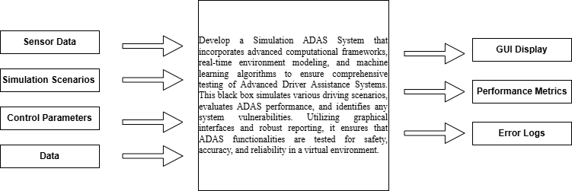

*Fig 6.1.1 Black Box of the ADAS System*

**6.1.2 Block Diagram of the Simulation**

* **Software Block Diagram of the simulation**

Fig 6.1.2 represents the block diagram of this project, illustrating a meticulously designed simulation system for self-driving cars. The main components of the system include multiple detection and analysis modules integrated for seamless operation. Input terminals are connected to cameras and sensors,to capture environmental data. The processing units handle lane detection, traffic signal recognition, and sign classification, ensuring real-time decision-making capabilities.The system features a powerful control module that manages steering, acceleration, and braking actions through precise calculations of lane curvature, traffic state, and proximity to nearby objects. Advanced components, such as the object detection module, improve obstacle avoidance, while a dedicated path planning algorithm ensures optimal routing.To enhance versatility, the simulation incorporates three virtual environments, each representing different road scenarios like urban, highway, and residential areas. These environments include dynamic objects like other vehicles and pedestrians for realistic testing. The simulation is further equipped with a virtual dashboard, allowing users to monitor and adjust system parameters in real time. This holistic design ensures accurate simulation of real-world conditions, enabling the development of a highly adaptive and efficient self-driving car system.

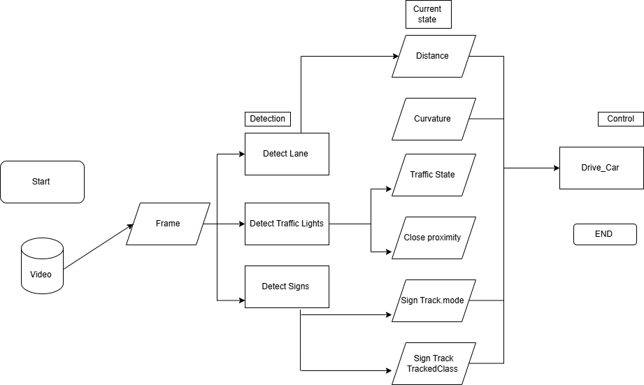

*Fig 6.1.2 Simulation Block Diagram of the ADAS System*

**6.1.3 Functions and Sub-Functions of the ADAS System**

**FUNCTIONS OF THE ADAS SYSTEM:**

*Table 6.1.3a Functions of the ADAS System*

| **SI. No** | **Functions** | **Descriptions** |
| --- | --- | --- |
| **1** | Data Acquisition | Collects data from multiple sensors like cameras to provide real-time environmental input for the simulation. |
| **2** | Object Detection and Tracking | Detects and tracks vehicles and other objects on the road using advanced algorithms. |
| **3** | Lane Detection and Keeping | Identifies lane markings and ensures proper lane positioning through simulation analysis.. |
| **4** | Collision Avoidance | Simulates potential collision scenarios and calculates corrective actions to ensure safety |
| **5** | Traffic Sign Recognition | Recognizes traffic signs and simulates appropriate responses, such as speed adjustments or stopping when necessary. |
| **6** | Path Planning and Decision-Making | Generates safe and efficient driving paths by analyzing current road conditions and predicting vehicle behavior. |
| **7** | Driver Behavior Simulation | Models driver responses under various scenarios, including sudden braking, acceleration |
| **8** | System Safety and Monitoring | Ensures the simulation operates within safe parameters, continuously monitoring performance and identifying faults. |
| **9** | Digital Twin | Creates a real-time digital replica of the ADAS system for remote monitoring, performance analysis, and optimization. |
| **10** | User Interface and Communication | Provides an intuitive interface for engineers and developers to interact with and analyze the simulation outcomes. |

**SUB FUNCTIONS OF THE ADAS SYSTEM:**

*Table 6.1.3b Sub-Functions of the ADAS System*

| **SI. No** | **Sub Functions** | **Descriptions** |
| --- | --- | --- |
| **1a** | Sensor Data Acquisition | Gather real-time data from sensors such as cameras, radar, and ultrasonic sensors to provide environmental information for the simulation.. |
| **1b** | Sensor Data Validation | Validate and filter sensor data to remove noise and ensure accuracy for further processing. |
| **2a** | Object Detection | Identify obstacles in the environment using advanced machine learning algorithms.. |
| **2b** | Object classification | Categorize detected objects into predefined types (e.g., traffic light , and sign boards ) to understand their behavior in the simulation. |
| **3a** | Lane Detection | Detect lane boundaries and markings to ensure simulated vehicles stay within proper lanes during the virtual drive. |
| **3b** | Lane Keeping Control | Simulate corrective actions to keep the virtual vehicle in the center of the lane based on the detected boundaries. |
| **4a** | Collision Scenario Simulation | Create scenarios to predict potential collisions and determine appropriate evasive actions to avoid them. |
| **4b** | Path Re-planning | Adjust driving paths dynamically in response to changing road conditions or detected hazards. |
| **5a** | Traffic Sign Recognition | Detect and interpret traffic signs in the simulation, enabling the system to respond to road rules and regulations. |
| **5b** | Traffic Signal Handling | Simulate the vehicle's interaction with traffic lights, including stopping, starting, and transitioning at intersections. |
| **6a** | Digital Twin Creation | Build a digital replica of the ADAS system to visualize and monitor performance during real-time simulations. |
| **6b** | Fault Analysis | Analyze errors and faults in the simulation to improve system robustness and reliability. |
| **7a** | Performance Monitoring | Track system behavior and evaluate performance metrics such as response time, accuracy, and efficiency during the simulation. |
| **7b** | Real-Time Feedback Integration | Provide continuous feedback to adjust and improve the system's decisions and responses during live simulations. |
| **8a** | User Interface and Reporting | Provide a clear and intuitive interface for users to visualize simulation results and generate detailed performance reports. |
| **9a** | Real-time Data Synchronization | Ensures that the digital representation of the Software system is always in line with it, allowing for immediate analysis and decision-making based on operational data that is current. |
| **9b** | Simulation and Visualization | enhances comprehension and makes data-driven improvements possible by facilitating the virtual representation of the simulation process and enabling engineers to monitor and adjust system behavior in real-time simulations. |
| **10a** | Operator Interface | Provide operators an easy-to-use interface so they can enter customer information, monitor the system, and deal with exceptions. |
| **10b** | Communication Protocols | Establish communication protocols for seamless integration with external systems and data exchange. |

**6.1.4 Use Case Diagram of the ADAS System**

Fig 6.1.4 represents the project's use case diagram which shows how important players—such as customers and super admins interact dynamically with the system features they use. While super admins are essential in managing the production process overall, supervising orders, and guaranteeing the upkeep of system functionalities, customers contribute by placing orders and checking their status. The Integrated Multi-Platform Automation System's visual representation effectively conveys the crucial user-system interactions and gives a thorough picture of the various stakeholders' contributions to the system's smooth operation.

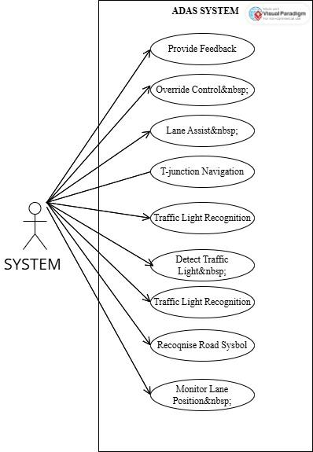

*Fig 6.1.4 Use Case of theADAS System*

**6.2 SOFTWARE OF THE ADAS SYSTEM**

*Table 6.2 Software used for the ADAS System*

| **Sl. No** | **Software used** | **Description** |
| --- | --- | --- |
| 1 | ROS2 | ROS 2 plays a pivotal role in simulating ADAS for self-driving cars by enabling seamless communication between sensors, perception, planning, and control modules. It integrates with simulators like Gazebo to test features such as lane detection, traffic light recognition, and obstacle avoidance in a virtual environment. ROS 2 supports real-time processing, modular architecture, and sensor fusion, making it ideal for scalable ADAS development. Debugging tools like Rviz and Gazebo GUI aid in visualizing and verifying algorithms during simulation. Additionally, ROS 2 bridges simulation and real-world deployment with minimal code modifications. |
| 2 | BLENDER | Blender is used in the simulation of ADAS for self-driving cars to design and create realistic 3D models of essential environment elements such as signboards (e.g., 30, 60, 90), traffic lights, symbols, and tracks. These models are created in Blender, then exported as .OBJ files for integration into simulation platforms like Gazebo. Blender ensures detailed, accurate, and visually realistic assets, which are crucial for testing perception algorithms. These models provide the virtual environment needed to evaluate ADAS features like traffic sign recognition and lane tracking. Its flexibility and precision make Blender a vital tool in developing simulation environments. |
| 3 | GAZEBO | Gazebo is used in the simulation of ADAS for self-driving cars to create realistic virtual environments by importing and arranging .OBJ models, such as traffic signs, lights, and tracks, into a cohesive simulation scene. These elements are rearranged and saved into .sdf files, which define their properties and placement. The finalized environment is saved as a .world file, which is loaded during simulations to test ADAS functionalities like object detection, lane tracking, and navigation. Gazebo provides physics-based simulation, sensor integration, and real-time visualization, making it an essential tool for validating self-driving car systems. |
| 4 | VS CODE | VS Code is used in the simulation of ADAS for self-driving cars as a powerful integrated development environment (IDE) for writing, debugging, and managing the project’s codebase. It supports languages like Python, C++, and XML, commonly used in ROS 2 and Gazebo configurations. With extensions for ROS, it aids in creating and editing launch files, node scripts, and simulation parameters. Its debugging tools and terminal integration streamline testing and troubleshooting. VS Code enhances productivity and ensures efficient development of ADAS algorithms and simulation setups. |

**6.2.1 3D World of the ADAS System**

ROS 2, Blender, Gazebo, and VS Code collectively enable the simulation of ADAS for self-driving cars by providing a comprehensive development and testing framework. ROS 2 facilitates seamless communication between sensors, perception, planning, and control modules, integrating with Gazebo to test features like lane detection, traffic light recognition .Blender is used to design and create realistic 3D models of traffic signs, lights, and tracks, which are exported as .OBJ files and integrated into Gazebo for simulation. Gazebo arranges these models into cohesive environments, saved as .world files, providing physics-based simulation and real-time visualization for validating ADAS functionalities. VS Code serves as a robust IDE for writing, debugging, and managing project code, with extensions for ROS to streamline configuration and testing. Together, these tools create a powerful ecosystem for developing, simulating, and validating self-driving car systems efficiently and accurately.



*Fig 6.2.1 3D World of the ADAS System*

**6.2.2 Lane Detection**

Lane detection is a crucial process in self-driving cars and involves several image-processing steps to identify lane markings accurately. First, the video frames are converted to grayscale, simplifying the data by focusing only on intensity variations, which highlight the contrast between lane markings and the road surface. The grayscale image is then transformed into a binary mask by applying a threshold, isolating the lane lines as white pixels while marking the rest as black. Edge detection algorithms, such as Canny Edge Detection or Sobel filters, are used next to emphasize the boundaries of the lane markings and remove noise. To ensure continuous lane detection, small gaps in the detected edges are connected using techniques like the Hough Line Transform or contour detection. Finally, the detected edges are refined into bounding boxes or smooth continuous lines, representing the lanes. This processed data is used to guide lane-keeping or lane-changing algorithms in ADAS and self-driving systems.

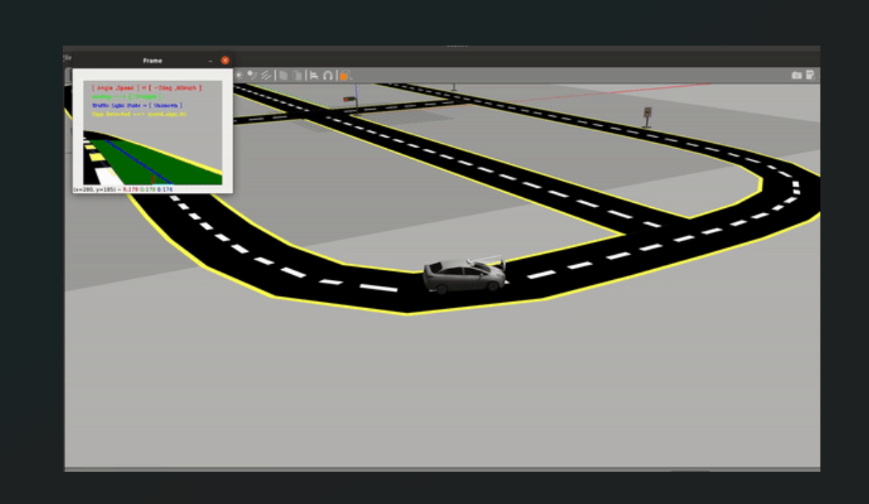

*Fig 6.2.2 Lane Detection*

**6.2.3 Traffic signs board Detection**

Traffic sign board detection in a self-driving car simulation involves multiple steps to identify and interpret signs in the virtual environment. Blender is used to design realistic 3D models of traffic signs with clear symbols (e.g., speed limits such as 30, 60, 90) and export them as .OBJ files. These models are integrated into the Gazebo simulation environment, where they are arranged and saved in the .world file. During simulation, the car’s onboard camera or virtual sensors capture the scene, and image processing techniques are applied to detect traffic signs. The video frame is analyzed using methods like Haar cascades, HOG (Histogram of Oriented Gradients), or convolutional neural networks (CNNs) to identify and classify signs based on their shape, color, and symbols. Once detected, the sign’s information (e.g., speed limit) is processed and used to adjust the car’s behavior, such as limiting speed or issuing warnings, ensuring safe navigation.

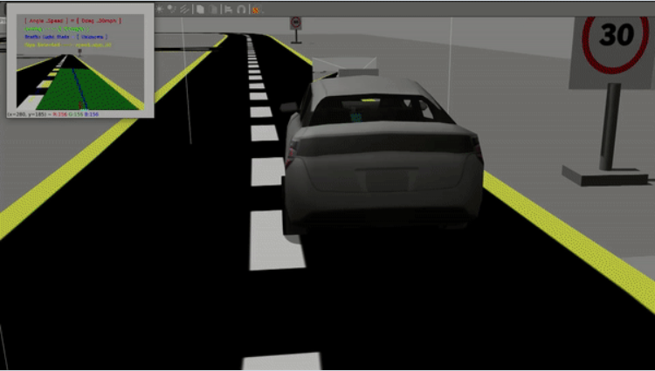

*Fig 6.2.3a Traffic sign board Detection*

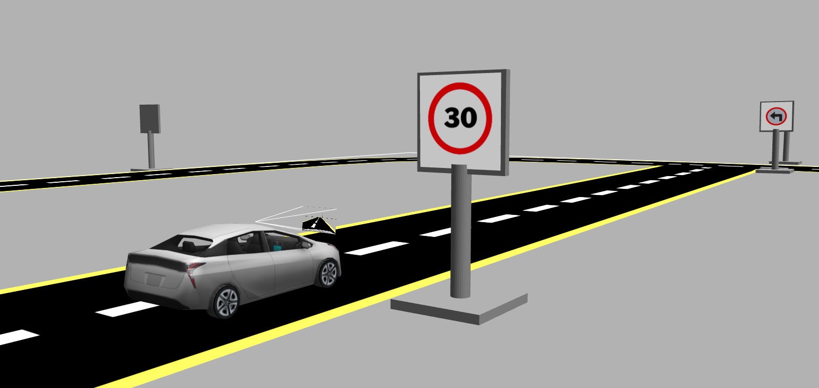

*Fig 6.2.3b Traffic sign board Detection*

**6.2.4 Traffic signal detection**

Traffic signal detection in a self-driving car simulation involves using computer vision techniques to identify and track traffic lights in the environment. Blender is used to create realistic 3D models of traffic signals, which are exported as .OBJ files and integrated into the Gazebo simulation. During simulation, the car’s onboard virtual camera captures the scene, and image processing methods, such as Haar cascades and Hough Circle Transform, are applied to detect the traffic signals. Once detected, the system analyzes the signal's state (e.g., Red, Green, or Unknown) based on color classification and position tracking using Optical Flow. This information is then used to control the car's behavior, such as stopping at red lights or proceeding on green, ensuring compliance with traffic rules in the simulated environment.

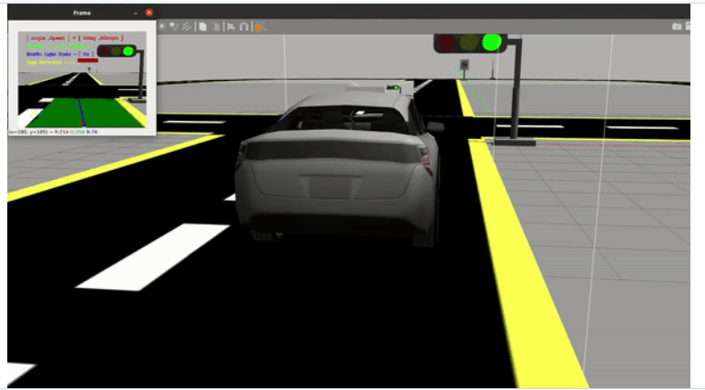

*Fig 6.2.4a Traffic signal Detection*

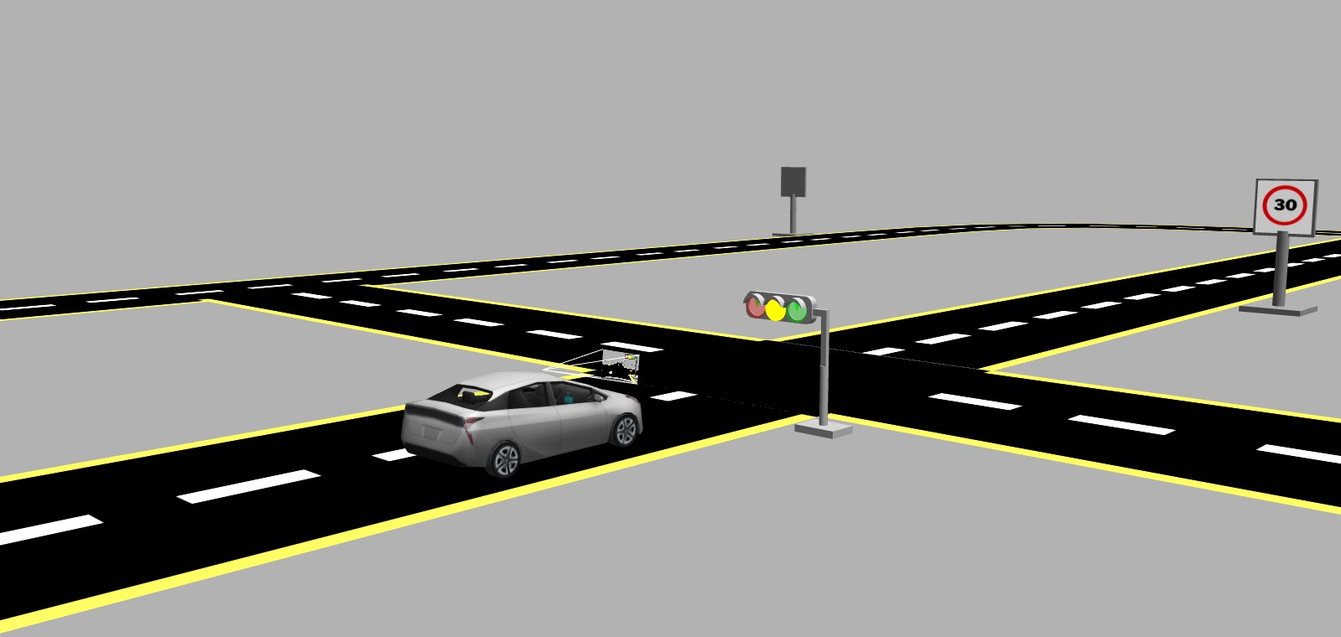

*Fig 6.2.4b Traffic signal Detection*

**T-Junction Navigation**

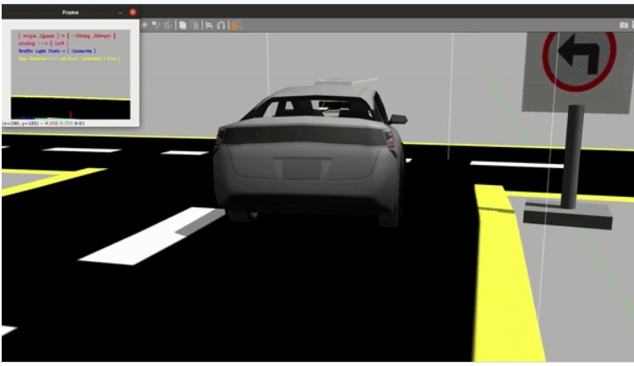

*Fig 6.2.4c T-Junction Navigation*

**6.3 WORKING MODEL OF THE PROJECT**

**Working:**

Fig 6.3bThe traffic signal detection in the ADAS system begins with the camera capturing real-time frames from the simulation environment. These frames are preprocessed through resizing, normalization, and thresholding to enhance image clarity and simplify the detection process. Using advanced computer vision techniques like Haar cascades or color segmentation, the system identifies traffic signals in the frame and classifies their state as Red, Green, or Amber. Based on the classified signal state, the decision-making module determines the appropriate vehicle response: stopping for a red light, proceeding for a green light, or cautiously responding to an amber light depending on proximity. The vehicle's control system then adjusts its speed or braking in real-time to ensure compliance with the signal. Additionally, the GUI provides real-time updates, displaying the detected signal state and the vehicle's response, enabling effective monitoring and analysis. This robust process ensures safe and efficient traffic navigation within the ADAS simulation.

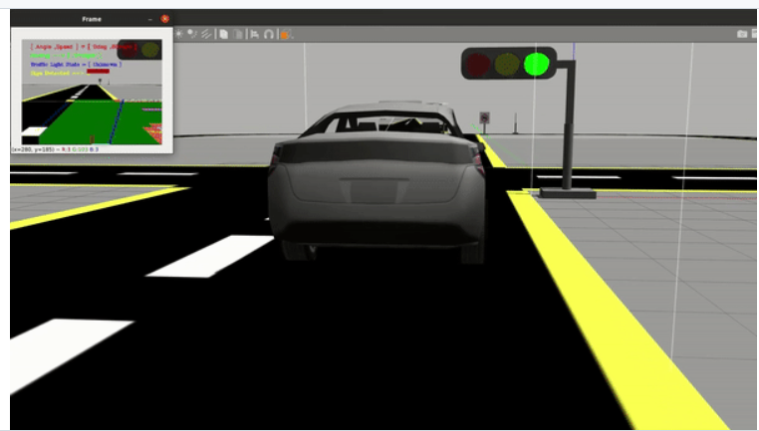

*Fig 6.3a Final prototype of the Project for traffic signal detection*

The above given Fig 6.3a represents the ADAS final prototype that coordinates a thorough and effective self-driving process process.

The traffic sign board detection in the ADAS system begins with the vehicle's camera capturing real-time frames from the simulation environment. These frames are preprocessed using resizing, normalization, and thresholding to enhance clarity and simplify sign detection. The system utilizes a CNN-based traffic sign recognition model to detect and isolate traffic signs in the frame, focusing on shapes, symbols, and text patterns. Once detected, the signs are classified into specific categories such as speed limits, warnings, or mandatory instructions. The classified information is passed to the decision-making module, which determines the appropriate action, such as reducing speed to comply with speed limit signs or issuing alerts for cautionary signs. The vehicle's control system implements the required adjustments in real-time, such as slowing down or notifying the driver through the GUI. This efficient process ensures accurate interpretation of traffic signs, enabling safe and regulation-compliant navigation within the ADAS simulation environment.

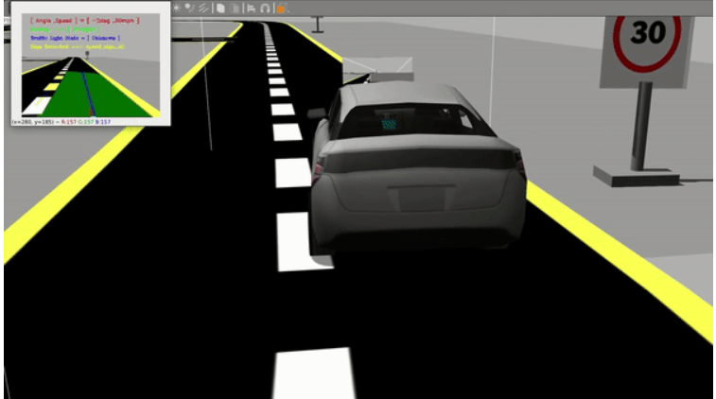

*Fig 6.3b Final prototype of the Project for traffic sign detection*

The T-junction navigation in the ADAS system begins with the camera and sensors capturing real-time data from the simulation environment to detect the road structure. The frames are preprocessed to highlight key features like lane markings and road edges. Lane detection algorithms identify the layout and orientation of the T-junction by analyzing changes in lane continuity and the presence of intersecting paths. Once the T-junction is detected, the system utilizes the decision-making module to determine the appropriate action based on road rules, surrounding traffic, and the direction of navigation (left, right, or straight). The system may halt the vehicle to ensure safety or provide instructions to proceed. Real-time control signals are then sent to the vehicle's actuators, adjusting steering and speed for smooth and accurate navigation.Throughout the process, the GUI provides a live visual representation of the detected T-junction and the system's decision, ensuring effective monitoring. This comprehensive workflow ensures safe and precise navigation through T-junctions in the ADAS simulation environment.

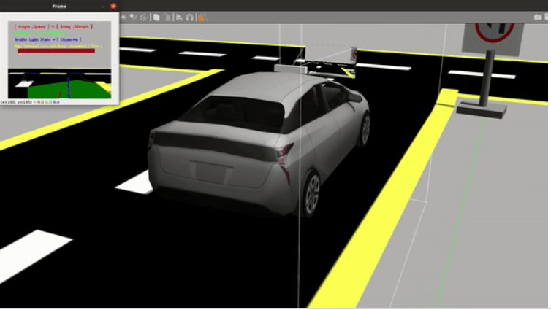

*Fig 6.3c Final working of t junction for ADAS System*

**CHAPTER 7**

**RESULTS**

The outcomes of the project demonstrate a variety of success factors.

* **Real-time Lane Detection**: The system demonstrates high accuracy in detecting and predicting lane boundaries in real-time, ensuring seamless navigation within the simulation environment.
* **Traffic Signal Recognition**: The ADAS system accurately identifies traffic signal states (Red, Green, Amber) from live frames, enabling precise control decisions such as stopping or proceeding.
* **Traffic Sign Recognition**: The system efficiently recognizes various traffic signs, including speed limits and warnings, and responds appropriately by adjusting speed or issuing alerts.
* **T-Junction Navigation**: The simulation successfully navigates complex intersections like T-junctions, showcasing effective path planning and decision-making capabilities.
* **Integrated Decision-Making**: The fusion of outputs from lane detection, signal recognition, and sign recognition modules results in a robust and coordinated decision-making process.
* **Vehicle Control System**: The control module ensures real-time adjustments in speed, steering, and braking, maintaining smooth and safe vehicle operations.
* **Real-time Data Logging**: All simulation data is recorded and updated in real-time, providing valuable insights for further analysis and refinement.
* **GUI Visualization**: Operators and stakeholders gain an in-depth overview of the ADAS system's performance through a user-friendly GUI, which displays all system activities and decisions.
* **Enhanced Safety and Accuracy**: The simulation sets new benchmarks for safety, accuracy, and responsiveness, proving its potential for real-world ADAS implementations.
* **Scalability and Modular Design**: The modular architecture allows easy scalability for incorporating additional features or expanding the scope of ADAS functionalities in future simulations.

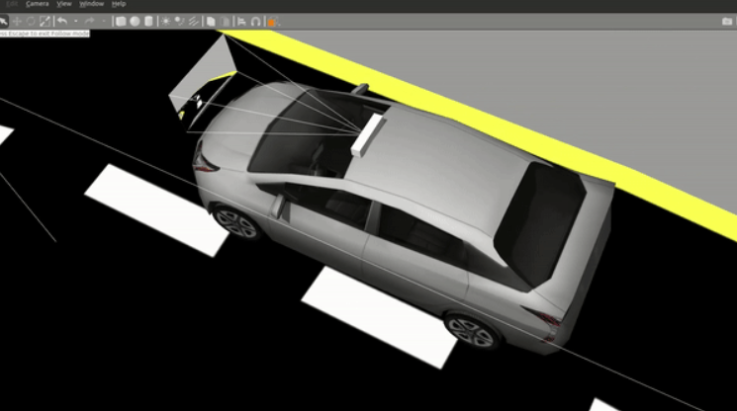

*Fig 7a Final model*

The final model in the ADAS system integrates multiple features, including lane detection, traffic signal and sign recognition, and T-junction navigation, into a unified framework. It uses real-time camera feeds and sensor data, processed through advanced algorithms, to make intelligent decisions for safe and efficient vehicle control. The system demonstrates seamless navigation, precise environment perception, and real-time responsiveness, providing a robust platform for testing and validating autonomous driving technologies in a simulated environment.

**CHAPTER 8**

**CONCLUSION**

The simulation of the ADAS (Advanced Driver Assistance System) project demonstrates the effectiveness of leveraging modern technologies such as ROS 2, Gazebo, and advanced image processing techniques to replicate and test real-world scenarios. The project successfully integrates lane detection, traffic signal recognition, traffic sign recognition, and T-junction navigation into a unified system, showcasing its ability to make real-time, intelligent decisions for safe and efficient vehicle operation. With accurate detection, classification, and control systems in place, the simulation sets a foundation for developing robust ADAS technologies. The results highlight the potential of these systems to improve road safety, reduce human errors, and enhance the driving experience. The user-friendly GUI and real-time data insights further add to the project’s utility, making it an essential tool for ADAS development and validation.

**Future Scope:**

**Real-world Implementation**: Extend the system from simulation to real-world scenarios by deploying the algorithms on physical vehicles equipped with appropriate sensors and actuators.

**Advanced Features**: Incorporate additional ADAS functionalities such as adaptive cruise control, pedestrian detection, and parking assistance to expand the system's capabilities.

**Sensor Fusion**: Integrate advanced sensor technologies like LIDAR, radar, and GPS for enhanced perception and localization in diverse environments.

**Edge Computing**: Optimize computational efficiency by implementing edge-based ADAS processing, enabling real-time decision-making in vehicles with limited onboard resources.

**Environmental Adaptability**: Enhance the system to perform reliably under varying weather conditions, such as rain, fog, or snow, by incorporating robust data augmentation and processing techniques.

**AI Integration**: Use deep learning and reinforcement learning models to improve decision-making and adapt to dynamic traffic scenarios.

**Interconnected Vehicles**: Explore vehicle-to-vehicle (V2V) and vehicle-to-infrastructure (V2I) communication for a collaborative and networked ADAS environment.

**Regulatory Compliance**: Develop the system to comply with regional and international road safety standards, paving the way for widespread adoption.

**Scalability**: Adapt the system for different types of vehicles, from passenger cars to commercial trucks, ensuring broader applicability across industries.

**REFERENCES**

[1] C. Maag, D. Muhlbacher, C. Mark and H. -P. Kruger, "Studying Effects of Advanced Driver Assistance Systems (ADAS) on Individual and Group Level Using Multi-Driver Simulation," in IEEE Intelligent Transportation Systems Magazine, vol. 4, no. 3, pp. 45-54, Fall 2012, doi: 10.1109/MITS.2012.2203231.

[2] T. Hanke, N. Hirsekorn, B. Dehlink, A. Rauch, R. Rasshofer and E. Biebl, "Generic architecture for simulation of ADAS sensors," 2015 16th International Radar Symposium (IRS), Dresden, Germany, 2015, pp. 125-130, doi: 10.1109/IRS.2015.7226306.

[3]CITATION: Zhou, J., Schmied, R., Sandalek, A., Kokal, H. et al., "A Framework for Virtual Testing of ADAS," SAE Int. J. Passeng. Cars – Electrons. Electr. Syst. 9(1):2016, doi:10.4271/2016-01-0049.

[4]S. Moten, F. Celiberti, M. Grottoli, A. van der Heide and Y. Lemmens, "X-in-the-loop advanced driving simulation platform for the design,development, testing and validation of ADAS," 2018 IEEE Intelligent Vehicles Symposium (IV), Changshu, China, 2018, pp. 1-6, doi: 10.1109/IVS.2018.8500409.

[5] M. Borg, R. B. Abdessalem, S. Nejati, F. -X. Jegeden and D. Shin, "Digital Twins Are Not Monozygotic – Cross-Replicating ADAS Testing in Two Industry-Grade Automotive Simulators," 2021 14th IEEE Conference on Software Testing, Verification and Validation (ICST), Porto de Galinhas, Brazil, 2021, pp. 383-393, doi: 10.1109/ICST49551.2021.00050. keywords:

[6] A. Hussein, A. Díaz-Álvarez, J. M. Armingol and C. Olaverri-Monreal, "3DCoAutoSim: Simulator for Cooperative ADAS and Automated Vehicles," 2018 21st International Conference on Intelligent Transportation Systems (ITSC), Maui, HI, USA, 2018, pp. 3014-3019, doi: 10.1109/ITSC.2018.8569512.

[7] Shakouri, P., Czeczot, J. & Ordys, A. Simulation Validation of Three Nonlinear Model-Based Controllers in the Adaptive Cruise Control System. *J Intell Robot Syst* **80**, 207–229 (2015). https://doi.org/10.1007/s10846-014-0128-4

[8] D. Metahri and K. Hachemi, "Optimization of free-fall-flow-rack automated storage and retrieval system dimensions," 2017 First International Conference on Embedded & Distributed Systems (EDiS), Oran, Algeria, 2017, pp. 1-6, doi: 10.1109/EDIS.2017.8284042Xiao, L., Wang, M., & van Arem, B. (2017). Realistic Car-Following Models for Microscopic Simulation of Adaptive and Cooperative Adaptive Cruise Control Vehicles. Transportation Research Record, 2623(1), 1-9.

[9]S. Stević, M. Krunić, M. Dragojević and N. Kaprocki, "Development and Validation of ADAS Perception Application in ROS Environment Integrated with CARLA Simulator," 2019 27th Telecommunications Forum (TELFOR), Belgrade, Serbia, 2019, pp. 1-4, doi: 10.1109/TELFOR48224.2019.8971063.

[10]F. A. Schiegg, J. Krost, S. Jesenski and J. Frye, "A Novel Simulation Framework for the Design and Testing of Advanced Driver Assistance Systems," 2019 IEEE 90th Vehicular Technology Conference (VTC2019-Fall), Honolulu, HI, USA, 2019, pp. 1-6, doi: 10.1109/VTCFall.2019.8891221.

[11] M. R. Zofka, R. Kohlhaas, T. Schamm and J. M. Zöllner, "Semi Virtual simulations for the evaluation of vision-based ADAS," 2014 IEEE Intelligent Vehicles Symposium Proceedings, Dearborn, MI, USA, 2014, pp. 121-126, doi: 10.1109/IVS.2014.6856593.

[12]R. Molenaar, A. van Bilsen, R. van der Made and R. de Vries, "Full spectrum camera simulation for reliable virtual development and validation of ADAS and automated driving applications," 2015 IEEE Intelligent Vehicles Symposium (IV), Seoul, Korea (South), 2015, pp. 47-52, doi: 10.1109/IVS.2015.7225661.

[13] F. Reway, W. Huber and E. P. Ribeiro, "Test Methodology for Vision-Based ADAS Algorithms with an Automotive Camera-in-the-Loop," 2018 IEEE International Conference on Vehicular Electronics and Safety (ICVES), Madrid, Spain, 2018, pp. 1-7, doi: 10.1109/ICVES.2018.8519598.

[14]V. A. Butakov and P. Ioannou, "Personalized Driver/Vehicle Lane Change Models for ADAS," in IEEE Transactions on Vehicular Technology, vol. 64, no. 10, pp. 4422-4431, Oct. 2015, doi: 10.1109/TVT.2014.2369522.

[15] L. Yue, M. A. Abdel-Aty, Y. Wu and A. Farid, "The Practical Effectiveness of Advanced Driver Assistance Systems at Different Roadway Facilities: System Limitation, Adoption, and Usage," in IEEE Transactions on Intelligent Transportation Systems, vol. 21, no. 9, pp. 3859-3870, Sept. 2020, doi: 10.1109/TITS.2019.2935195.